Beta glucagon
Beta glucagon may be defined as a heterogeneous natural polysaccharide comprising mainly d-glucose monomers coupled with a beta glycosidic bond. The polysaccharides are considered an essential constituent of prokaryotes’ (e.g., bacteria and fungi) cell walls, acting as energy tankage. Usually, beta glucagon is found in oats, barley, mushroom and yeast. The (1,3)-β, (1,4)-β, or (1,6)-β glycosidic bonds are very common in the glucose submit of beta glucagon. In 1941 Pillemer L et al. was the first man who observed the immune-modulatory action of beta glucagon in the hydrophobic fraction yeast [1]. Then in 1955, it was reported that the immunological activity of such formulation was elicited from β-(1,3)-D-glucans [2]. Beta glucagon derives from fungi and yeast showed its immunological action through different mechanisms. The first mechanism involves the activation of macrophages which provide adequate stimulation to B-lymphocytes, natural killer cells, and suppressor T-cell [3-5]. In this case, the beta-glucan act as an effective immune stimulator. The second mechanism (in vitro) annexes with the indirect stimulation of cytokines, IL-1 or TNF; as a result, the microbiocidal effect of human neutrophils and macrophages increase significantly and protect the body from disease-causing pathogens [6-10], and the third proposed mechanism of beta glucagon is relevant to the promptness of dectin-1 pattern recognition receptor (PRR), an essential immune-stimulating receptor that plays a crucial role on blood peripheral mononuclear cells [11,12]. In phagocytosis, only insoluble beta glucagon can mediate apoptosis by binding with dectin-1 [13]. However, the soluble beta glucagon combines with complement receptor 3 (CR3) involved in complement-mediated immune processes provided by particular antibodies [13]. The human body, in general, cannot able to produce beta glucagon. To make it convenient, the human immune system initially receives beta-glucan as a stranger. Then, using pattern recognition receptors (PRR), the innate immune system makes it competent to combat against harmful pathogens. Here, the most important immune-stimulating role is played by PRR as it recognizes the action of pathogen-associated molecular pattern molecules (PAMPs) and therefore, beta glucan is marked as one of the efficient agonists of PAMPs [14,15] and other immune cells as well.

Ginseng
Ginseng is derived from the root of Panax ginseng, and Araliaceae family belonging medicinal herb employed as a herbal remedy for 3000 years ago, recognized by the traditional Chinese practitioners [16]. In general, two prominent types of ginseng is used for treatment purposes, the first one is named white ginseng, which is also known as naturally dried ginseng, and the second one is named red ginseng, which is made by applying steam before the drying process so that it can easily retain its safety profile, efficacy, and conservancy [17]. The presence of several bioactive constituents like ginsenosides (tetracyclic triterpenoid saponins), polyacetylenes, acidic polysaccharides, and polyphenolic compounds make it a unique biological plant for treatment purposes [18]. Based on chemical makeup, ginsenosides can further divide into three subtypes: subtype A) protopanaxadiol include Rb1, Rb2, Rb3, Rc, and Rd sub-type B) protopanaxatriol includes Re, Rf, Rg1, and Rg2 and sub-type C) oleanane includes Ro [18,19]. Ginseng is an influential immune stimulator as it stimulates both innate and acquired immune systems [20–23]. The innate immune system demonstrates its effect through macrophages, dendritic cells, and natural killer cells. In 2002, Shin JY et al. ascertained that ginseng extract formulation exaggerates the phagocytosis cycle through stimulation of macrophages [24]. Further, red ginseng acidic polysaccharides (RGAPs) or ginseng treated macrophages can generate nitric oxide (NO), which acts as troops for killing phagocytized microbes [25]. According to the study of Choi HS et al., the production of IL-1β, TNF-α, and NO reaches the peak point when macrophages have been treated with RGAPs and IFN-γ [25]. An analogous activity has been found in murine J774A.1 macrophage cells and ginseng extract, which augment the secretion of interleukin-12 [26]. Dendritic cells, another vital part of the innate immune system, matured as a steroidal saponins end product (e.g., M1 and M4) provoke the expression of MHC class II, CD 80, CD 83, and CD 86 so-called dendritic cells markers [27]. In addition, ginseng extract and ginsenoside Rg-1 are responsible for promoting the activity of natural killer cells [21,28]. In contrast, the acquired immunity system consists of the humoral immune response, cell-mediated immune response, and cytokine release factors. Liou CJ et al. reported that oral or intraperitoneally administered ginseng extract could incite the production of IgM, IgG, and IgA antibody responses successfully [29,30]. Moreover, subcutaneous administration of ginsenoside Rg1 and ginsenoside reproduces antibodies against Toxoplasma gondii and improves serum-specific antibodies e.g., Ig, IgG_{1,} IgG_{2a}, IgG_{2b} against H₃N₂ influenza virus, respectively [31,32] in the cell-mediated immune system. Therefore, Kim KH et al. claimed that in vitro cultured of ginseng and spleen cells may increase the secretion of many cytokines like IL-1α, IL-2, granulocyte-macrophage colony-stimulating factor (GMCSF) production and IFN-γ [33] (Fig. 1).
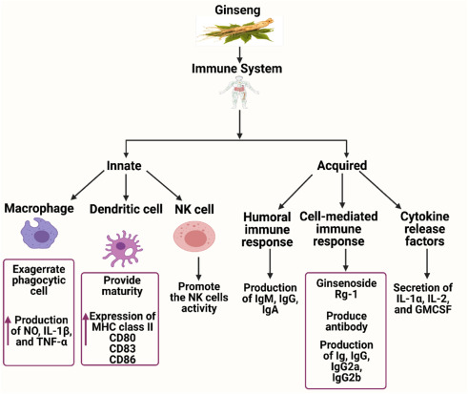
Figure viewer
Fig. 1 Schematic presentation of Ginseng and immune cells mechanism. Ginseng is closely associated with both innate and acquired immune responses. Its innate immune function is mediated through macrophages, dendritic cells and NK cells, where the acquired immune response is facilitated through various humoral, cell-mediated and cytokine release factors.

Vitamin C
Vitamin C or ascorbic acid is an essential hydrophilic micronutrient that has played a vital role in fostering the function of immune cells more than a jubilee [34,35]. It is involved in various synthetic processes and acts as a cofactor in several biological reactions like hydroxylation of collagen, biosynthesis of norepinephrine and carnitine, and regulation of hypoxia-inducible factor (HIF), metabolism of tyrosine, demethylation of histone and peptide hormone amidation [36]. Scottish physician James Lind in 1757, first observed that scurvy-affected patients got healed soon after they had taken fresh citrus fruits. Later, fresh citrus fruits and lemon juice were obligatory for British navy sailors [37]. Then, in 1907 Axel Holst and Alfred Frohlich claimed the existence of a particular substance in fresh citrus fruits and lemon juice [37]. Five years later (1912), Casimir Funk named the particular substance vitamin C [38] and cited that this vital substance had kept the body from diseases. After that, in 1928, scientist Albert Szent-Györgyi was able to isolate vitamin C, and finally, in1933, scientists were capable of synthesizing vitamin C [39]. Vitamin C has played a pivotal role in enhancing the activity of the immune system. It's functioning on neutrophils, chemotaxis, and phagocytes is well established [40]. Wilson et al. reported that vitamin C directly activates the lymphocytic cell through activation of SVCT (sodium-dependent vitamin C transporters) and GLUT (sodium-independent glucose transporters) [41]. Due to the activation of SVCT and GLUT, the intracellular plasma concentration of vitamin C increases about 10–100-fold than in normal conditions [42,43], which exaggerates T-cell, B-cell, and natural killer cells. In vitro study of Huijskens, M. J et al. narrated that vitamin C plays a key in the early maturation of T-cell as it removes the hindrance of the T-cell maturation process [44].
Further, daily intaking of 100 mg/kg/day vitamin C supplementation in two months may take up the activities of CD28 cells and cytokine factors [45]. In 2018, Van Gorkom GN et al. [46] cited in their review that vitamin C is responsible for the differentiation of helper T cell −1(Th-1) with the expenditure of helper T-cell polarization (Th-2). Another in vitro study on mice models reported that Vitamin C helps to generate CD8⁺ memory T cells by stimulating cytokines derived from dendritic cells [47]. In addition, vitamin C is requisite for the proper functioning of regulatory T -cell (Treg) through activation of Foxp3, the so-called master transcription factor in the epigenetic system [48,49]. In terms of B-cell, Prinz et al. found that vitamin C supplementation had enhanced the I_{G} concentration when guinea pigs had been immunized with red blood cells of sheep and serum albumin of bovine, respectively [50,51]. In the case of natural killer cells (NK), the role of vitamin C is somehow controversial; however, according to the in vitro report of cytokine-stimulated cell culture study, vitamin C is involved in the maturation and proliferation of natural killer cells that derive from peripheral blood mononuclear cells [52] (2).
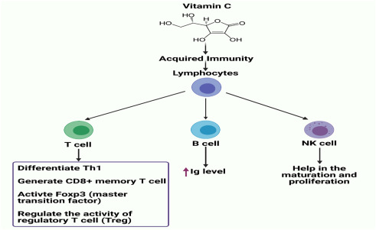
Figure viewer
Fig. 2 Schematic presentation of Vitamin C and immune cells mechanism. The activity of specific lymphocytic cells (e.g., T cell, B cell and NK cell) is boosted by ascorbic acid. Ascorbic acid helps to regulate the activity of Th1, CD8⁺, Foxp3, Treg and Ig levels.

Vitamin E
Lipid or fat-soluble vitamin E is composed of mainly four tocopherols (α, β, γ, and δ) and four tocotrienols (α, β, γ, and δ) and all of these forms are available in different food sources. Although all of these isoforms are associated with antioxidant properties, α-tocopherol is the only one that may fulfill the human nutritional requirements [53]. Vegetable oils contribute to the significant sources of vitamin E supplementation. More than 50 mg vitamin E/100 g oil has been found in wheat germ oils, cottonseed, corn, soybean, sunflower, walnut, and palm. Sheppard et al. reported that nuts contain a good amount of vitamin E [54]. The primary role of vitamin E is to scavenge the harmful peroxyl radicals and mitigate the oxidation of fatty acids, particularly the chain reactions of poly-unsaturated fatty acids; therefore, vitamin E protects the essential immune cells precisely. The various studies indicate that vitamin E is closely associated with crucial immune cell functions, e.g., macrophages, dendritic cells, B-cells, and natural killer cells. The immune-modulating activity of vitamin E on macrophages is triggered by the downregulation of prostaglandin E_{2,} which promotes the immune response of T-cells related to the aging process [55]. Wu et al. cited that in vivo vitamin E supplementation in aged mice model could vanquish the synthesis of prostaglandin E₂ and cyclooxygenase −2 remarkably generated from macrophages [56]. A similar type of activity has been observed by Beharka et al., where his investigation reported that vitamin E suppressed the activity of cyclooxygenase-2 in macrophages through scavenging the activity of peroxynitrite [57].
Further, taking 1500 IU d-α-tocopheryl acetate/day supplementation in 16 weeks inhibits the expression of macrophage nuclear factor erythroid 2-related factor 2 (NRF-2) and protects against allergies and asthmas [58]. In the case of NK cells, Adachi et al. reported that 100 mg/d vitamin E supplementation in an eight-week protocol could regain CD16⁺ CD56⁺ and NK cells [59]. To find out the correlation between NK cell cytotoxicity and vitamin E, Ravaglia et al. conducted an observational study on 37 female individuals (aged 90–106) who had been treated with vitamin E supplementation. At the end of the study, the author cited that the cytotoxic activity of NK cells largely depends on vitamin E supplementation [60]. According to the description of Buendía et al. [61], vitamin E supplementation may enhance the activity of protein Klotho by inhibiting the activity of dendritic cell-based nuclear factor-beta (NF-ҡB). Klotho is one kind of membrane protein that may regulate the transport of intracellular calcium control the signaling pathway of p53/p21, cAMP (cyclic adenosine monophosphate), PKC (protein kinase C), and NF-ҡB (nuclear factor-beta) [61]. Vitamin E supplementation shows its immune-stimulating effect on T-cells by augmenting the cell division and interleukin-2 secretion, as Adolfsson et al. [62] reported. Further, from the observational study on an old animal model, Marko et al. noted that vitamin E mediated T-cells may generate efficient immune synapse and help to mitigate the defect of the aging process [63,64]. In addition, vitamin E plays a significant role in balancing the activity of helper T cell-1(Th1) and helper T cell-2(Th2) [54]. On the other hand, a few clinical studies claimed that vitamin E is associated with antibody production of B-cell mediated humoral responses, although some investigators suggested further clinical trials [65,66] (Fig. 3).
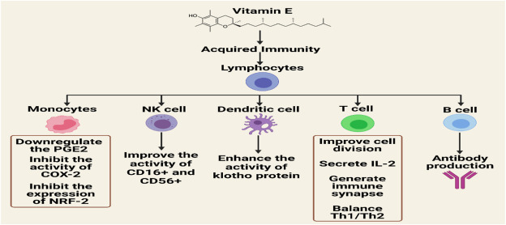
Figure viewer
Fig. 3 Schematic presentation of Vitamin E and immune cells mechanism. The immunomodulatory function of Vitamin E is to downregulate PGE2, COX-2 and NRF-2 and upregulate the activities of CD16⁺, CD56⁺, Klotho protein, IL-2, Th1/Th2 and antibody production.

Zinc
Zinc is one of the most influential and vital trace elements mandatory for the accrual and anabolism of all living organisms [67-70]. Raulin was the first researcher who revealed that zinc is necessary for amplifying Aspergillus nigar in 1869 [67]. Then Todd WR et al. (1934) conducted a study on the rat model where they found that zinc played a pivotal role in growth and development [68]. For proper functioning of enzymes, transcription, and replication factors, this trace element zinc acts as a co-factor to exaggerate their activity [71,72]. The zinc concentration in human plasma is in a very minute amount, 12–16 μmol/L, but due to mobility characteristics in the circulatory system, its immunological action is phenomenal [73,74]. Again, Scott, B. J. et al. noted that in serum, zinc could quickly form a bond with serum protein molecules [75] and alter the immunological functions. From previous studies, it is clear that zinc is essential for maintaining normal immune function, and lack or deficiency of zinc may suppress the activities of human innate and acquired immunity [76]. Any depletion in zinc concentration directly interferes with the action of neutrophil granulocytes and chemotaxis of the innate immune system in vitro [77]. Hujanen et al. reported that zinc at the concentration of 500 μmol/L might provide adequate stimulation to carry out the chemotactic activity in polymorphonuclear leukocytes, noteworthy [78]. In vivo study of Allen et al. narrated that due to insufficient zinc level in the body, the phagocytic activity of macrophages, neutrophils, natural killer cells, and oxidative burst were greatly suffered and lost their immune-modulating activities [79,80]. The same phenomenon has been seen in granulocytes, as zinc deficiency proportionally decreases the number of granulocytes [1]. Further, the immune-modulating activity of specific immune cells (B and Tell) is closely associated with zinc supplementation. From previously reported studies, it is clear that zinc's influence on T cells and more specific than B-cell [2,3]. It has been thought that the generation of B-cell precursors is obliged to induce apoptosis due to the unavailability of zinc supplementation [4]. Minigari et al. speculated that zinc might affect the activities of both NK cell-mediated killing mission and cytotoxic T-cell [81]. The immune-modulating activity of T -cell precursors CD8+and CD73⁺ do not show their physiological effect if there is a zinc deficiency in the body [82]. Mention that, CD73⁺ is crucial for recognizing or proliferating the specific antigen and also provides a trigger to accelerate the cytolytic process [83]. Thymic atrophy is a very common phenomenon of T-cell-related zinc deficiency [84]. Thymulin hormone is generated from the thymus gland and secreted from epithelial cells of the thymic membrane with the help of zinc cofactor [85,86]. Zinc co-factor help the T-cell mediated physiological function by various mechanistic way. Firstly, zinc aid in the differentiation and development of both immature and mature T-cell that are located in the thymus and periphery respectively. After that, zinc stimulates the cytokine release factors with the help of peripheral blood mononuclear cells (PBMC) which then animate both CD8⁺ T cells and interleukin-2 and therefore disclose the high affinity receptor for interleukin-2 of mature T-cell [87–88]. In order to address the problem of zinc deficiency on thymus and peripheral cells, zinc supplementation could be an excellent solution to meet the desired vacant immune requirements [84] (Fig. 4).
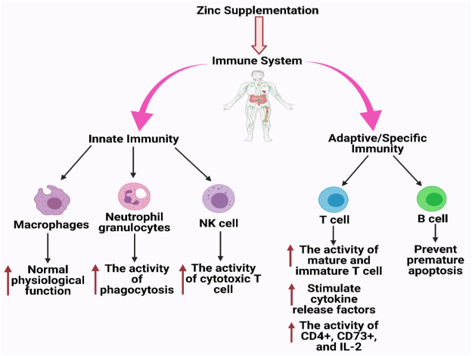
Figure viewer
Fig. 4 Schematic presentation of Zinc and immune cells mechanism. Zinc supplementation is responsible for providing adequate immune stimulation of innate immune cells like macrophages, neutrophils, NK cells, and specific immune cells like-cell and B-cell precisely.

